Rectangle Practical exam   
Name: Michael Ryan Lingad  
  
  
Form:

* Basically inside the Group box we have 3 rectangular panels colored Blue, Yellow and Red.

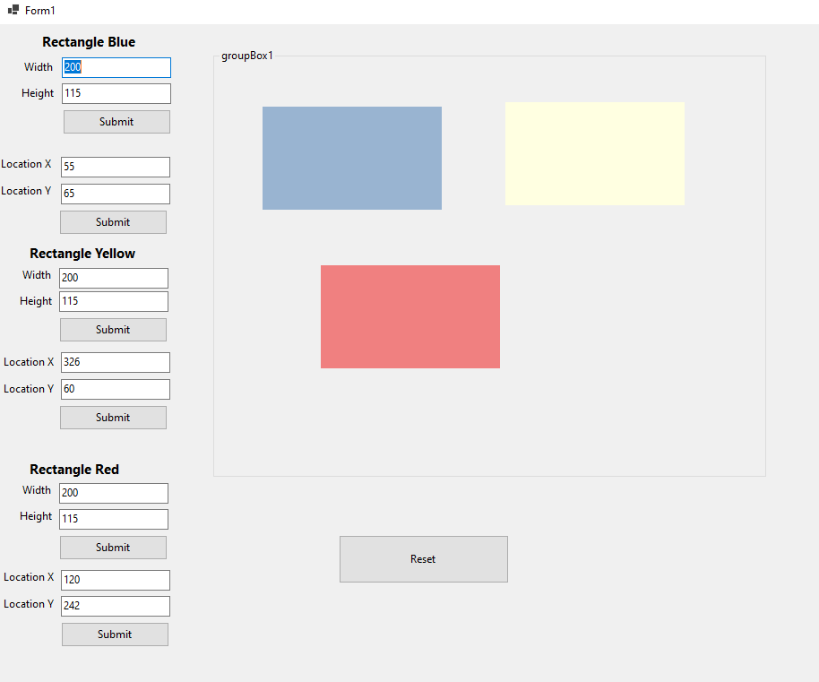

* Adjust the value of width and height then hit the submit button below the textbox. Notice that the size of the rectangular panel will change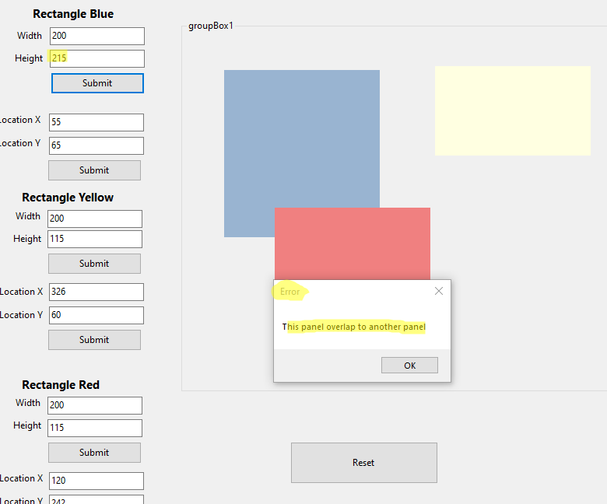
* . If the adjusted size of the Panel will overlap to the other 2 panels a pop up message will display the error and after clicking the ok button the size or the rectangle will return to its previous size. Same logic applies to location.
* 